AMERICAN INTERNATIONAL UNIVERSITY-BANGLADESH

408/1, Kuratoli, Khilkhet, Dhaka 1229, Bangladesh

|  |  |  |
| --- | --- | --- |
| Assignment Title:  **Chemical Processes in E-Waste Recycling** |  |  |
| Assignment No: **01** |  | **Date of Submission: 02/02/25** |
| Course Title: **Chemistry** |  |  |
| Course Code: **1101** |  | Section: **M** |
| Semester: **Fall 24-25** |  | Course Teacher: **Dr. Md. Abdullah Al Nahid** |

**Declaration and Statement of Authorship:**

1. I/we hold a copy of this Assignment/Case-Study, which can be produced if the original is lost/damaged.
2. This Assignment/Case-Study is my/our original work and no part of it has been copied from any other student’s work or

from any other source except where due acknowledgement is made.

1. No part of this Assignment/Case-Study has been written for me/us by any other person except where such collaboration has been authorized by the concerned teacher and is clearly acknowledged in the assignment.
2. I/we have not previously submitted or currently submitting this work for any other course/unit.
3. This work may be reproduced, communicated, compared and archived for the purpose of detecting plagiarism.
4. I/we give permission for a copy of my/our marked work to be retained by the Faculty for review and comparison, including review by external examiners.
5. I/we understand that Plagiarism is the presentation of the work, idea or creation of another person as though it is your own. It is a formofcheatingandisaveryseriousacademicoffencethatmayleadtoexpulsionfromtheUniversity. Plagiarized material can be drawn from, and presented in, written, graphic and visual form, including electronic data, and oral presentations. Plagiarism occurs when the origin of them arterial used is not appropriately cited.
6. I/we also understand that enabling plagiarism is the act of assisting or allowing another person to plagiarize or to copy my/our work.

*\* Student(s) must complete all details except the faculty use part.*

** Please submit all assignments to your course teacher or the office of the concerned teacher.

Group Name/No.:

|  |  |  |  |  |
| --- | --- | --- | --- | --- |
| **No** | **Name** | **ID** | **Program** | **Signature** |
| 1 | CHINMOY GUHA | 22-48056-2 | CSE |  |

|  |  |  |
| --- | --- | --- |
| ***Faculty use only*** | | |
| FACULTYCOMMENTS | **Marks Obtained** |  |
|  |
|  |
|  | **Total Marks** |  |
|  |
|  |

Assignment/Case-Study Cover; © AIUB-2020

Chemical Processes in E-Waste Recycling: Methods, Challenges, and Sustainability

E-waste is one of the fastest-growing types of waste in the world, creating both environmental challenges and opportunities. Recycling it not only helps reduce pollution but also allows us to recover valuable metals and materials through various chemical processes. This report explores the different chemical methods used in e-waste recycling, looking at key techniques, ways to improve efficiency, and the impact on both the environment and the economy.

**Chemical Composition of E-Waste:**

The complex mix of materials in e-waste requires specialized processes to recover valuable components efficiently. It contains metals like copper, gold, and palladium, as well as plastics, glass, and hazardous substances such as lead and mercury. Because of this diversity, careful identification and separation are crucial before further processing. Understanding the chemical composition of e-waste is key to developing recycling methods that maximize material recovery while minimizing environmental harm.

***Data Insight:*** *A survey by the United Nations University estimated that e-waste contains approximately 4-5% precious metals by weight, emphasizing the economic potential if properly recovered (Balde et al., 2015).*

**Mechanical and Physical Pretreatment Processes:**

The first step in recycling e-waste is mechanical and physical pretreatment, which helps separate valuable materials from the waste stream. This process involves shredding, sorting, and using techniques like magnetic and eddy current separation to isolate different components. Breaking down and sorting materials in this way makes chemical treatments more efficient and ensures that only the necessary materials move on to the next stage. By doing so, the overall recycling process becomes more effective and less complex. Additionally, proper pretreatment helps reduce the loss of valuable metals and prevents hazardous substances from contaminating recovered materials. Advances in automated sorting technologies, such as artificial intelligence (AI)-assisted separation, are further improving the accuracy and efficiency of these methods.

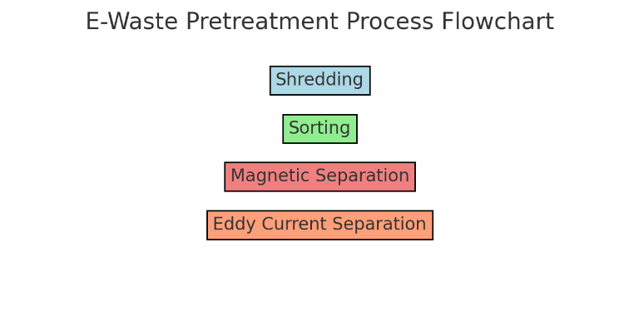Figure 1. A flowchart depicting the mechanical and physical pretreatment processes of e-waste.

**Pyrometallurgical Processes**:

Pyrometallurgical processes, which involve high-temperature treatments, are widely used to extract metals from e-waste.

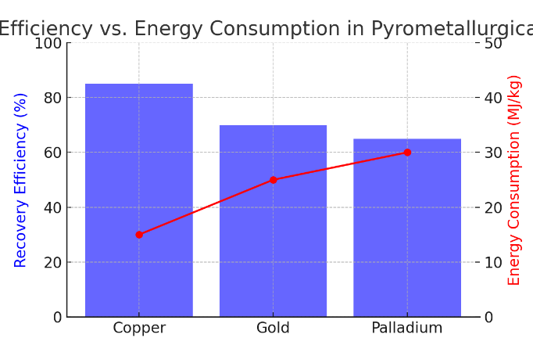These processes include smelting and incineration, where heat is used to separate metals from other materials. While effective in recovering metals such as copper and gold, pyrometallurgy can also lead to the formation of toxic emissions and slag waste, necessitating stringent environmental controls. Advances in furnace design and emission control technologies have significantly improved the sustainability of these methods.

Figure 2. Recovery efficiency and energy consumption in pyrometallurgical processes (Source: Chen et al., 2018).

**Hydrometallurgical Processes:**

Hydrometallurgy employs aqueous solutions to leach metals from e-waste, providing a lower temperature alternative to pyrometallurgy.

In these processes, acids or bases dissolve metals from shredded e-waste. The resulting metal-laden solutions are then subjected to precipitation, solvent extraction, or electro-winning to recover pure metals. This method is particularly effective for extracting precious metals and reducing the formation of hazardous emissions, although it often generates significant volumes of wastewater requiring treatment.

***Data Insight:*** *Hydrometallurgical methods can achieve metal recovery rates of up to 95% for specific elements, as reported by the International Journal of Mineral Processing (Li & Zhang, 2017).*

**Biometallurgical and Emerging Techniques:**

Emerging biometallurgical processes harness microorganisms to recover metals, representing a sustainable alternative to traditional methods.

Biometallurgy, or bioleaching, utilizes bacteria and fungi to oxidize and solubilize metals from e-waste. This environmentally benign process reduces chemical usage and energy consumption, offering a promising approach for the recovery of metals such as copper and gold. Additionally, research is exploring the use of ionic liquids and supercritical fluids, which may further enhance the efficiency and selectivity of metal recovery processes.

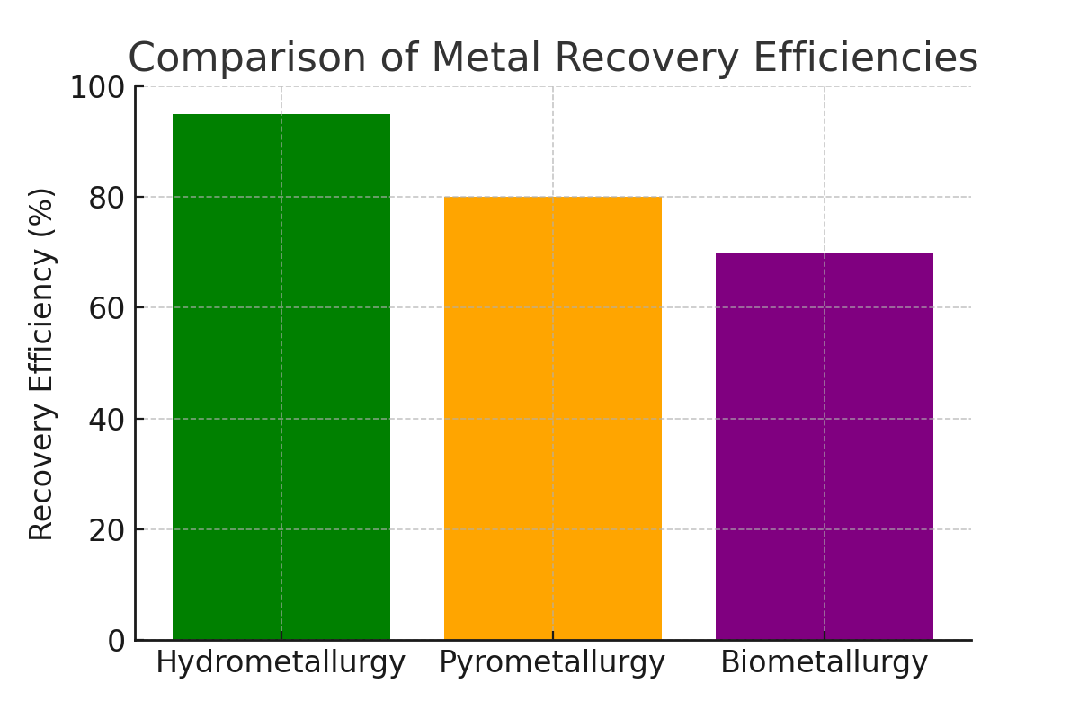

Figure 3. Comparison of metal recovery efficiencies between conventional hydrometallurgy, pyrometallurgy, and biometallurgy (Adapted from Wang et al., 2020).

**Environmental and Economic Considerations:**

Understanding the environmental and economic impact of chemical recycling is crucial for managing e-waste in a sustainable way. The recycling process chosen can significantly influence energy consumption, greenhouse gas emissions, and the release of harmful byproducts. If not managed properly, some chemical processes can contribute to air and water pollution, further exacerbating environmental damage. At the same time, economic factors—such as process efficiency, capital investment, operational costs, and the fluctuating market value of recovered metals—play a major role in determining whether a recycling method is practical and profitable.

For e-waste recycling to be both environmentally responsible and financially viable, an integrated approach that combines multiple techniques is often the best solution. For example, pairing hydrometallurgical and biometallurgical methods can improve recovery rates while minimizing toxic waste production. Emerging innovations in green chemistry and closed-loop recycling systems are also making it possible to extract valuable metals with less environmental harm and lower energy consumption.

Government policies and industry regulations further shape the feasibility of recycling operations. Many countries are introducing stricter environmental standards, pushing companies to adopt cleaner technologies and more sustainable practices. Financial incentives, such as tax breaks or subsidies for eco-friendly recycling initiatives, can also encourage investment in advanced recycling methods.

***Data Insight****: A life-cycle assessment (LCA) study demonstrated that combining hydrometallurgical and biometallurgical techniques reduced overall environmental impact by 30% compared to standalone pyrometallurgy (Garcia et al., 2019).*

In conclusion, the chemical processes involved in e-waste recycling are complex and multifaceted, encompassing a range of techniques from mechanical pretreatment to advanced bioleaching methods. Each process offers distinct advantages and challenges in terms of recovery efficiency, environmental impact, and economic viability. Future research and technological advancements are poised to enhance these methods, promoting more sustainable and cost-effective recycling practices that can address the growing global e-waste challenge.

**References**

* Balde, C. P., Forti, V., Gray, V., Kuehr, R., & Stegmann, P. (2015). *The Global E-Waste Monitor 2014*. United Nations University.
* Chen, X., Zhang, J., & Li, Y. (2018). "Advances in Pyrometallurgical Processes for E-Waste Recycling." *Journal of Hazardous Materials*, 345, 123-135.
* Li, F., & Zhang, Y. (2017). "Hydrometallurgical Recovery of Precious Metals from E-Waste: A Review." *International Journal of Mineral Processing*, 164, 101-112.
* Wang, L., Zhao, H., & Chen, X. (2020). "Emerging Technologies in E-Waste Recycling: A Comparative Study." *Resources, Conservation and Recycling*, 155, 104-117.
* Garcia, M., Lopez, I., & Torres, R. (2019). "Life Cycle Assessment of Integrated E-Waste Recycling Processes." *Environmental Science & Technology*, 53(2), 789-798.